**Task one simulation**

**[Bank Multi-Channel Queue]**

|  |  |
| --- | --- |
| Name | ID |
| Hassan samir hassan | **20200154** |
| Khaled Fahmy Mohamed | **20200169** |
| Ahmed Sameh Ahmed | **20200015** |
| Ahmed Mahmoud Sliem Andallah | **20210622** |

**Problem formulation & Objectives**

**Formulation:**

One teller is available to assist customers at a bank. Customers are divided into two categories: regular customers and distinguished customers. Each category has its own queue. that displays the interval between arrivals and service time for regular customers and the notable customers' service times and the interval between arrivals. A waiting distinguished customer will be served before a waiting ordinary customer because distinguished customers are given more priority to be served.

However, the appearance of a notable customer cannot interfere with the servicing of a regular customer.

**Objectives:**

* The average service time of the teller.
* The average waiting time in the ordinary customers queue and the distinguished customers queue.
* The maximum ordinary customers queue length and the distinguished customers queue length.
* The probability that an ordinary customer wait in the queue, and the probability that a distinguished customer wait in the queue.
* The portion of idle time of the teller.
* Does the theoretical average service time of the service time distribution match with the experimental one for both types of customers?
* Does the theoretical average inter-arrival time of the inter-arrival time distribution match with the experimental one for both types of customers?
* If there is an additional teller to serve the distinguished customers only, how does this affect the average waiting time in the queues of both types of customers?

**System Components**

* **System:** Bank Multi Channel Queue
* **Entity:** Customer (distinguished ,ordinary )
* **Attributes:** teller
* **Activities:** time between the arrival of Customer (distinguished ,ordinary ) and the next and time in system is running and service time (distinguished ,ordinary )
* **State:** The number of distinguished or regular customers who are in the waiting queue
* **Events:** idle or busy teller in the bank

**System analysis including cumulative distribution tables**

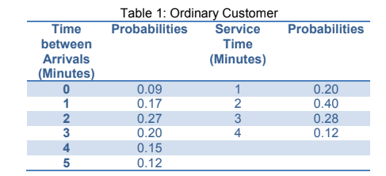

|  |  |  |
| --- | --- | --- |
| Time between Arrivals  (Minutes) | Probabilities | cumulative |
| 0 | 0.09 | 0.09 |
| 1 | 0.17 | 0.26 |
| 2 | 0.27 | 0.53 |
| 3 | 0.20 | 0.73 |
| 4 | 0.15 | 0.88 |
| 5 | 0.12 | 1 |

|  |  |  |
| --- | --- | --- |
| Service time  (Minutes) | Probabilities | cumulative |
| 1 | 0.20 | 0.20 |
| 2 | 0.40 | 0.60 |
| 3 | 0.28 | 0.88 |
| 4 | 0.12 | 1 |

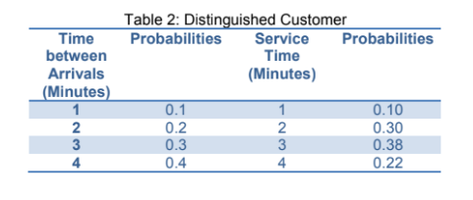

|  |  |  |
| --- | --- | --- |
| Time between Arrivals  (Minutes) | Probabilities | cumulative |
| 1 | 0.1 | 0.1 |
| 2 | 0.2 | 0.3 |
| 3 | 0.3 | 0.6 |
| 4 | 0.4 | 1 |

|  |  |  |
| --- | --- | --- |
| Service time  (Minutes) | Probabilities | cumulative |
| 1 | 0.10 | 0.10 |
| 2 | 0.30 | 0.40 |
| 3 | 0.38 | 0.78 |
| 4 | 0.22 | 1 |

**calendar table (for 20 customers)**

**Experimental Design Parameters**

* Inter arrival time for ordinary customers : Random following given distribution
* Inter arrival time for Distinguished customers : Random following given distribution
* Service time for ordinary customers : Random following given distribution
* Service time for Distinguished customers : Random following given distribution

**Justification of experiment parameters values**

* Number of customers(n) : this the variable to store number of customer by user
* O : counter to ordinary customer
* D: counter to Distinguished customer

**Results Analysis:**

* The average service time of the teller: 2.7
* The average waiting time in the Ordinary Customer: 1.9
* The average waiting time in the Distinguished Customer: 0.6
* the Ordinary Customer queue length: 10
* the Distinguished Customer queue length: 10
* The probability that an ordinary Customer: 0.5
* The probability that an Distinguished Customer: 0.3
* The portion of idle time of the teller: 0.31645569620253167

**Results Analysis:**

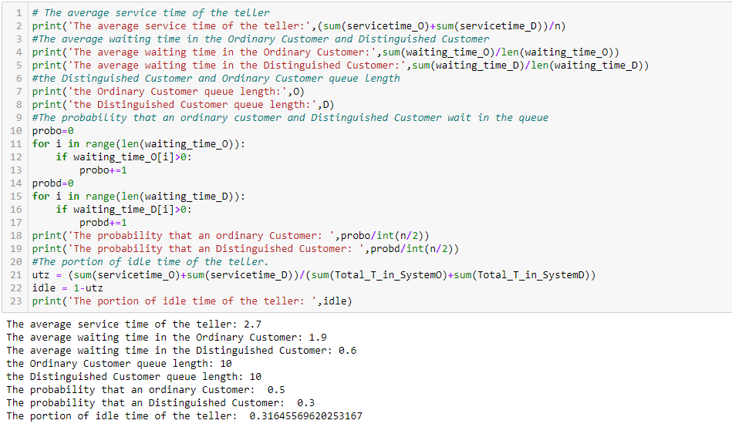

**Data Visualization**

